I can complete 20 Activities in this guide to learn:


- What a “deepfake” is and understand how they are created using artificial intelligence (AI), as well as how to identify them.

- The societal impacts of deepfakes. This includes considering complex questions around free speech, disinformation, privacy and more.
20 Activities start now!
1/20 | ✏️Write your name:

2/20 | ✏️Your class period:

3/20 | 🔍Find the deepfake: One of these photos is real and one was generated by artificial intelligence (AI).
  Circle the image you think is the AI generated deepfake.
   | 
  Real or Fake? | Real or Fake?

4/20 | 👀Read the definition of a deepfake:  A fake piece of media, like an image or video, that is created by using AI to manipulate existing images, videos, and/or sounds.  Deepfakes are often deceptively realistic so it can be extremely difficult for humans to tell that they are fake.

5/20 | ✏️What do you KNOW about artificial intelligence (AI)? Write at least ONE (1) complete sentence in the space below.
Not sure? Try these sentence starters:
- AI has to do with computers being able to...
- Some people say AI could...
- I think AI involves...

6/20 | 💻Visit aiedu.org/ai-in-five to read the definition and interesting examples of AI.    Scan the QR Code to visit AI in Five  🔗aiedu.org/ai-in-five

💯Keep up the great work! There’s more on the next page …
▼
7/20 | ✏️What did you LEARN about AI from the AI in Five website? Write at least ONE (1) complete sentence in the space below.
Not sure? Try these sentence starters:
- One intriguing aspect I learned about AI is that...
- The website clarified that AI's ability to make decisions is based on…
- The website explained how AI learns from experience, which taught me that...

8/20 | 🎬Visit youtu.be/C8FO0P2a3dA to watch Deep Fakes: How They’re Made and How They Can Be Detected and learn more about deepfakes and democracy.    Scan the QR Code  to watch the video  youtu.be/C8FO0P2a3dA  🤿Diving Deeper (optional) - For more tips on how to detect a deepfake, read the article How To Detect a Deepfake at the end of the Student Guide [page 12].

9/20 | ✏️Can you describe one example of a deepfake? Write at least ONE (1) complete sentence in the space below.

10/20 | 👀Read the definition of a democracy:  Democracy is the system of government in the United States in which power comes from the people, who can elect leaders and participate in the political system through free and fair elections, open debate, and protected civil liberties. | 

11/20 | ✏️What is one way deepfakes can have a POSITIVE impact on democracy? Write at least ONE (1) complete sentence in the space below.

12/20 | ✏️What is one way deepfakes can have a NEGATIVE impact on democracy? Write at least ONE (1) complete sentence in the space below.

13/20 | 👀Read the definition of a press release:  Official releases from an organization with newsworthy information to inform the public and the press of something noteworthy. This could be the cast of a new Hollywood film project, a new product, a business’ earning report. White House press releases are created and distributed by the Office of the President.

14/20 | 👀Read about the project:  Deepfakes impact on political systems  In this project, you will be writing a White House press release that informs the American public about the potential benefits and harms of deepfakes. First, you must consider why it is important for the public to learn about deepfakes, especially as they relate to the American political system.  The term “fake news” is used often to describe incorrect information (disinformation) that is widely distributed. Disinformation can influence the way voters see themselves and the issues they care about. Deepfakes are a type of disinformation that can change people’s voting habits.

15/20 | 👀Read about what makes a good press release:  A press release is meant to announce an important and news-worthy story. White House press releases often communicate vital information to the American public. How do you write a press release that catches people’s attention and informs them without being long or boring?  - Know your audience. All writing is better if you know who your target audience is. Who will benefit the most from the information you are writing about?  - Write a clear and attention-grabbing headline. The headline, or title, of your press release must clearly express what the release is about and make a person want to read it.  - Answer the 5 W’s. Outline the who, what, why, when, and where of your topic.  - Add detail. Give your readers the important details without overwhelming them with unnecessary information. Readers can seek out more information if they want to.  - Write a conclusion. End the press release with a short conclusion that summarizes the important information and offers plans for next steps.

🎸You rock, keep rolling! There’s more on the next page …
▼
16/20 | 👀Read TWO (2) press release samples in the Student Guide [pages 7-8].
  Read sample #1 on Page 7  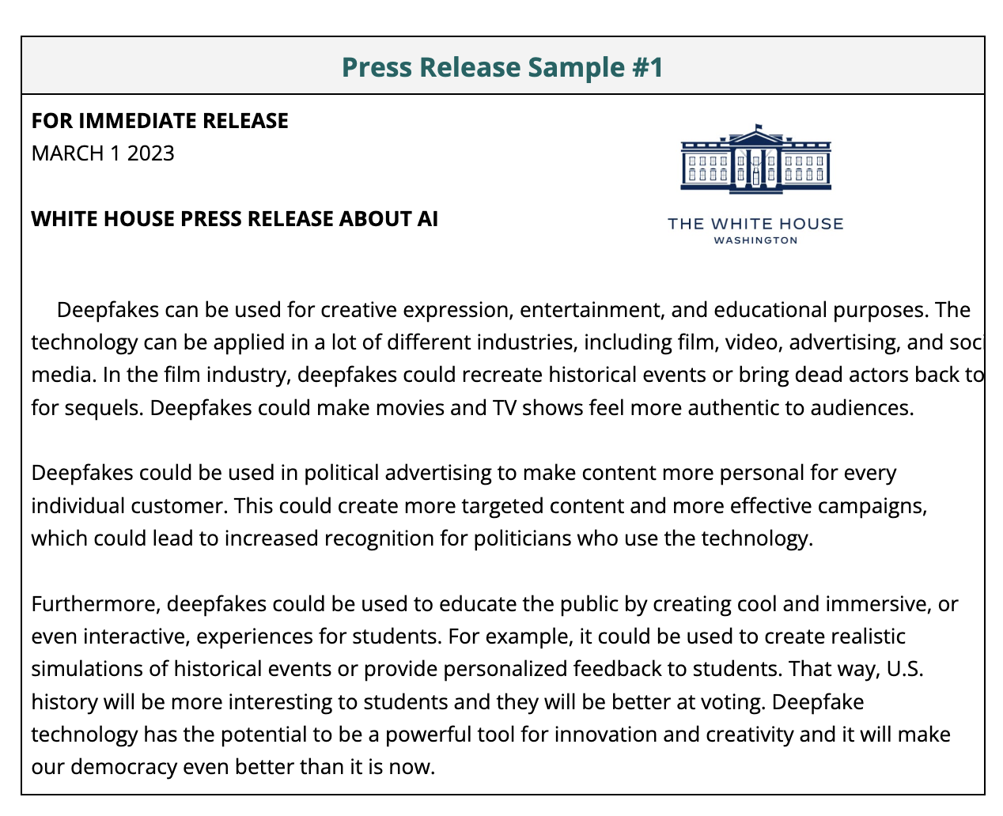 | Read sample #2 on Page 8  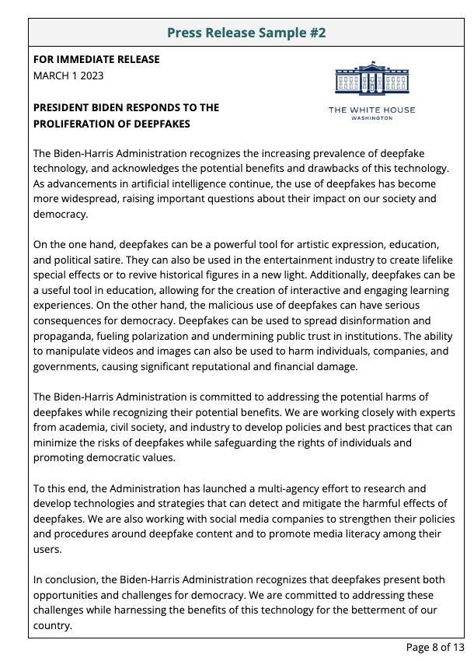
 | Not sure? Read about what makes a good press release (activity 15/20) and look for examples of a good press release in the samples (pages 7-8).

17/20 | ✏️In your opinion, which press release is more effective? Why? Write at least ONE (1) complete sentence in the space below.
 | Not sure? Read about what makes a good press release (activity 15/20) and look for examples of a good press release in the samples.


Press Release Sample #1
FOR IMMEDIATE RELEASE
MARCH 1 2023

WHITE HOUSE PRESS RELEASE ABOUT AI

Deepfakes can be used for creative expression, entertainment, and educational purposes. The technology can be applied in a lot of different industries, including film, video, advertising, and
social media. In the film industry, deepfakes could recreate historical events or bring dead actors back to life for sequels. Deepfakes could make movies and TV shows feel more authentic to audiences.

Deepfakes could be used in political advertising to make content more personal for every individual customer. This could create more targeted content and more effective campaigns, which could lead to increased recognition for politicians who use the technology.

Furthermore, deepfakes could be used to educate the public by creating cool and immersive, or even interactive, experiences for students. For example, it could be used to create realistic simulations of historical events or provide personalized feedback to students. That way, U.S. history will be more interesting to students and they will be better at voting. Deepfake technology has the potential to be a powerful tool for innovation and creativity and it will make our democracy even better than it is now.

Press Release Sample #2
FOR IMMEDIATE RELEASE
MARCH 1 2023

PRESIDENT BIDEN RESPONDS TO THE PROLIFERATION OF DEEPFAKES

The Biden-Harris Administration recognizes the increasing prevalence of deepfake technology, and acknowledges the potential benefits and drawbacks of this technology. As advancements in artificial intelligence continue, the use of deepfakes has become more widespread, raising important questions about their impact on our society and democracy.

On the one hand, deepfakes can be a powerful tool for artistic expression, education, and political satire. They can also be used in the entertainment industry to create lifelike special effects or to revive historical figures in a new light. Additionally, deepfakes can be a useful tool in education, allowing for the creation of interactive and engaging learning experiences. On the other hand, the malicious use of deepfakes can have serious consequences for democracy. Deepfakes can be used to spread disinformation and propaganda, fueling polarization and undermining public trust in institutions. The ability to manipulate videos and images can also be used to harm individuals, companies, and governments, causing significant reputational and financial damage.

The Biden-Harris Administration is committed to addressing the potential harms of deepfakes while recognizing their potential benefits. We are working closely with experts from academia, civil society, and industry to develop policies and best practices that can minimize the risks of deepfakes while safeguarding the rights of individuals and promoting democratic values.

To this end, the Administration has launched a multi-agency effort to research and develop technologies and strategies that can detect and mitigate the harmful effects of deepfakes. We are also working with social media companies to strengthen their policies and procedures around deepfake content and to promote media literacy among their users.

In conclusion, the Biden-Harris Administration recognizes that deepfakes present both opportunities and challenges for democracy. We are committed to addressing these challenges while harnessing the benefits of this technology for the betterment of our country.

18/20 | 🧩Use the Press Release Outline Template in the Student Guide [page 10] to PLAN your White House press release.  Your outline should include:  - A clear and catchy headline  - An audience (eg: your school? The country at large? Journalists?  - The 5 W’s for your introduction  - At least 3 important details you want to include to support your point  - Include two examples of deepfakes  - Include their positive and negative ramifications  - Two summarizing statements that will go in your conclusion  - Why is it important that this audience knows about deepfakes?  - What can this audience do to detect deepfakes and/or mitigate the negative consequences?

19/20 | 🧩Use the White House Press Release Template in the Student Guide [page 11] to WRITE your White House press release.  Your press release should:  - Be between 250 - 400 words  - Have a clear and descriptive headline  - Have at least 3 paragraphs:  - An introduction that introduces the topic and clearly explains the who, what, where, why, and when.  - A middle paragraph that includes important additional details  - A conclusion that summarizes the release and describes next steps

20/20 | ✏️Do you think the press release you wrote would make a big difference in combating fake news? Why or why not? Write at least ONE (1) complete sentence in the space below.

Press Release Outline Template

HEADLINE

Paragraph 1: Introduction
WHO
WHAT
WHERE
WHEN
WHY

Paragraph 2: What are at least 3 details you want to include in your second paragraph?
1
2
3

Paragraph 3: What are at least 2 statements you want to include in your conclusion?
1
2

🦾Digital Press Release Outline Template: Visit tinyurl.com/deepfakereleaseoutline or Scan the QR code to snag a digital version of the email template.



FOR IMMEDIATE RELEASE
[WRITE THE DATE IN THIS BOX]

[WRITE THE HEADLINE IN THIS BOX]

[WRITE THE BODY OF YOUR PRESS RELEASE IN THIS BOX]

🦾Digital Press Release Template: Visit tinyurl.com/deepfakepressrelease or Scan the QR code to snag a digital version of the email template.


🤿Diving Deeper (Optional) - Read the article below for tips on how to detect a deepfake.

How To Detect a Deepfake
The Conversation, July 2022
By Rob Cover, Professor of Digital Communication, RMIT University

One of the best remedies against harmful deepfakes is for users to equip themselves with as many detection skills as they can.

Usually, the first sign of a deepfake is that something will feel “off”. If so, look more closely at the subject’s face and ask yourself:
- Is the face too smooth, or are there unusual cheekbone shadows?
- Do the eyelid and mouth movements seem disjointed, forced or otherwise unnatural?
- Does the hair look fake? Current deepfake technology struggles to maintain the original look of hair (especially facial hair).

Context is also important:
- Ask yourself what the figure is saying or doing. Are they disavowing vaccines, or performing in a porn clip? Anything that seems out of character or contrary to public knowledge will be relevant here.
- Search online for keywords about the video, or the person in it, as many suspicious deepfakes will have already been debunked.
- Try to judge the reliability of the source – does it seem genuine? If you’re on a social media platform, is the poster’s account verified?

A lot of the above is basic digital literacy and requires exercising good judgment. Where common sense fails, there are some more in-depth ways to try to spot deepfakes. You can:
- Search for keywords used in the video to see if there’s a public transcript of what’s being said – outlets often cover quotes by high-profile politicians and celebrities within 72 hours.
- Take a screenshot of the video playing and do a Google reverse image search. This can reveal whether an original version of the video exists, which you may then compare to the dubious one.
- Run any suspicious videos featuring a “colleague” or “relative” by that individual directly.

Finally, if you do manage to spot a deepfake, don’t keep it to yourself. Always hit the report button.

